## 4.Book Library

First task is to "**GET**" all books. To consume the request with **POSTMAN** your **url** should be the **following**: **http://localhost:3030/jsonstore/collections/books**

Using the provided skeleton, write the missing functionalities.

Load all books by clicking the button "LOAD ALL BOOKS"

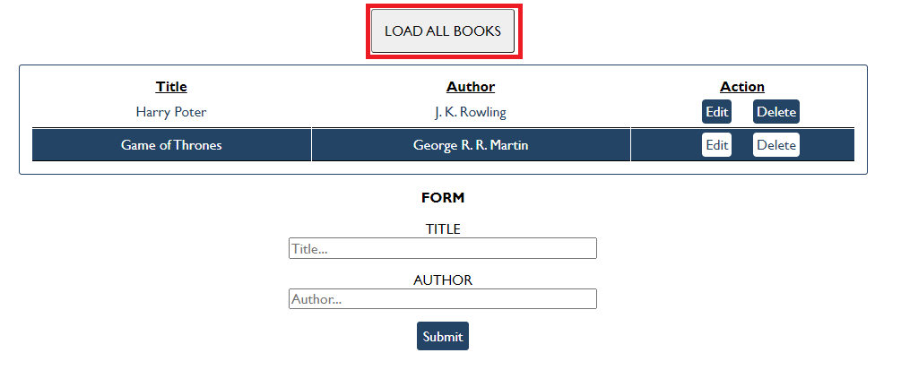

### Get Book

This functionality is not needed in this task, but you can try it with postman by sending request to "GET" the Book with id:" d953e5fb-a585-4d6b-92d3-ee90697398a0". Send a GET request to this URL:

**http://localhost:3030/jsonstore/collections/books/:id**

### Create Book

Write functionality to create a new book, when the submit button is clicked. Before sending the request be sure the fields are not empty (make validation of the input). To **create** a book, you have to send a "**POST**" request and the JSON body should be in the **following** format:

{

"author": "New Author",

"title": "New Title"

}

### Update Book

By clicking the edit button of a book, change the form like this:

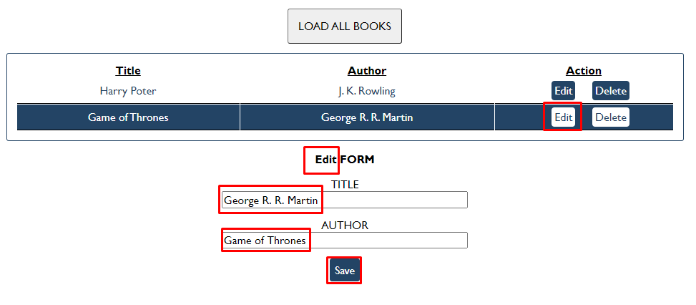

The HTTP command "**PUT**" **modifies** an existing HTTP **resource**. The URL is:

**http://localhost:3030/jsonstore/collections/books/:id**

The JSON body should be in the **following** format:

{

"author": "Changed Author",

"title": "Changed Title"

}

### Delete Book

By clicking the delete button you have to delete the book, without any confirmation. To delete a book use "**DELETE**" command and send **REQUEST**: [**http://localhost:3030/jsonstore/collections/books/:id**](http://localhost:3030/jsonstore/collections/books/:id)